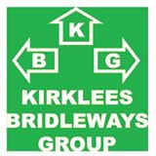
KIRKLEES BRIDLEWAYS GROUP
MEMBERSHIP FORM 2018
(1st January 2018 to 31st December 2018)
Name:

Address:

Post Code:
Telephone Number:
Mobile:
E-mail address:
Individual membership = £5.00
Family membership = £10.00
Please make cheques payable to: Kirklees Bridleways Group
And send with completed membership form to:
Janet Clift, The Hovel,Yew Tree Lane,Holmbridge,Holmfirth. HD9 2NR
Te;: 01484 680279
Or by BACS to:
HSBC - Kirklees Bridleways Group
Account No: 64248082 Sort Code: 40 25 10
Email or send your membership form to the address above or email to kirkleesbridlewaysgroup@gmail.com

