­­





I confirm that I have read and understood the terms and conditions of entry (tick box)



I am under 16 and will be accompanied by an adult

Signature of Parent or Guardian

I am over 16 but under 18 and will be riding unaccompanied by an adult

I am over 18

Tel

**Insurance**

All riders must have public liability insurance, valid on the day of the event. BHS Gold Membership includes up to £30 million public liability insurance cover (terms, conditions and territorial limits apply – full details on BHS website) The BHS is an Appointed Representative of South Essex Insurance Brokers Ltd who are authorised and regulated by the Financial Conduct Authority

Expiry date

BHS Gold Membership number

**Non-BHS Gold Members must provide evidence of cover**

Limit of indemnity £

Insurance company

Expiry date

Policy No.

**Emergency Contact and vehicle details**

Please provide these below in order to notify your preferred contact and locate your horsebox/trailer in the event of an emergency.

Emergency Contact

Name: Contact Number: Relation to you:

Vehicle Details

Make: Model: Registration:

**Rider details**

Full name

Address

Postcode

Email

Mobile

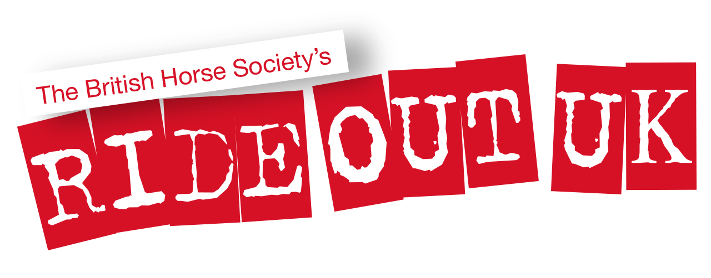

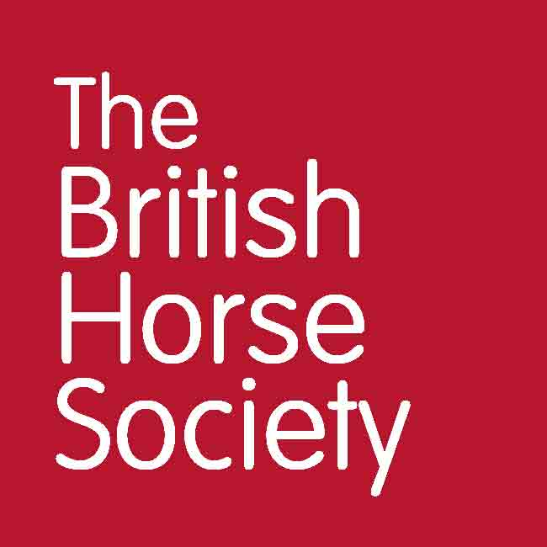

BHS and KBG Dunford Pleasure Ride

Entry Form

**Using your personal information**

Photographs may be taken on the day

**Permissions Form**

**Personal information** that you supply to us may be used in a number of ways. For example:

* To contact you about the event
* To promote the event to BHS members and the general public. For example:
  + on The British Horse Society website
  + in British Horse magazine
  + On The British Horse Society social media accounts
* **Insurance details** for non-members will be kept for seven years in case any insurance claim is brought
* **Photographs** may be used by The British Horse Society in printed, online or electronic publications, which may be shared publicly. Examples of these materials include, but are not limited to: posters, leaflets, brochures, adverts, emails, e-newsletters, blogs, web pages, social media posts, presentations, speeches, research or policy reports and press releases or other materials.

**I agree** / **do not agree** that photographs of **myself** may be used by The British Horse Society,

**I agree** / **do not agree** that photographs of **the child**, for whom I have parental responsibility for, may be used by The British Horse Society.

/ /

Date Signed Print

To see our full Privacy Notice, or if you need any further information, please write to:  
The British Horse Society, Abbey Park, Sareton, Kenilworth, Warwickshire, CV8 2XZ  
or visit [www.bhs.org.uk/privacy](http://www.bhs.org.uk/privacy)

Charges

£15 per rider | no refunds

Optional donation to BHS Ride Out Fund welcomed

Pay by bank transfer - Send the completed application form to

[kirkleesbridlewaysgroup@gmail.com](http://kirkleesbridlewaysgroup.co.uk/membership-form/mailto;%22kirkleesbridlewaysgroup@gmail.com%22)

and make a BACS transfer to: Kirklees Bridleway Group

Sort Code: 40-25-10 – Account No: 64248082

**Payment**

**BHS Ride Out UK Fund**

Creating new routes and restoring existing routes for you to ride and carriage drive.



Terms and Conditions

The British Horse Society is a Registered Charity Nos. 210504 and SC038516

General

* Please DO NOT ATTEND if you feel unwell with Covid-19 symptoms or have been in contact with someone with symptoms. Please inform the organiser if you need to withdraw and a refund will be arranged.
* Please do not arrive before your allocated time and please untack and depart as promptly as possible
* Only 1 rider plus 1 helper per horse (helpers must also complete a form for test and trace, kept for 6 months).
* Booking forms will be kept on record for 6 months for test and trace purposes
* Anyone that does not comply with event protocols will be asked to leave site immediately. There will be no exceptions to this rule.
* All attendees must keep a 2m distance at all times whilst on site and must stay in groups of no more than 6.
* There will be no passport or vaccination checking on the day. Please email a scanned copy in advance of the event. Please note: all passports must still travel with a horse as it is a legal requirement.
* All bookings must be paid for in advance. There will be no exchange of money on the day. Bookings will not be accepted on the day. No refunds, bar exceptions for Covid-19 or the event is cancelled due to unforeseen circumstances.
* Upon arrival, please follow the any instructions given by a marshal. You should get ready in the parking area, maintaining social distancing from all other households. Please park a minimum of 5m distance from the next lorry/trailer to allow for tying up on one side only.
* There will be no catering facilities on site so please bring your own refreshments with you. There are no toilets on site.
* All entrants must hold third party public liability insurance either through being a Gold member of The British Horse Society or via proof from another provider.
* All riders are responsible for ensuring the safety of themselves and others.
* Always ride with courtesy, care and consideration to fellow users of the route including equestrians, cyclists, walkers, particularly those who may be elderly, disabled, children, or simply be frightened of horses. Ride slowly past others.
* Leave gates as you find them and ride slowly past any livestock. Dogs ***are not permitted.*** If the event incorporates using a road, ensure the Highway Code is adhered to.

Riders

* Riders under 16 years must be accompanied by a responsible adult for the duration of the event.
* Hats to the current standard must be worn and correctly secured at all times when mounted. Please check yours meets current standards which can be found at[**http://www.bhs.org.uk/headwear**](http://www.bhs.org.uk/headwear)
* Body protectors are strongly recommended and should comply with current standards – also found on the BHS website at [**http://www.bhs.org.uk/body-protectors**](http://www.bhs.org.uk/body-protectors)
* All riders must wear suitable riding footwear. Wellington boots and trainers are not allowed.
* Riders are advised to carry a mobile phone and be aware of the emergency contact number for the event.

Horses

* All horses must be no younger than four years of age and be of an appropriate fitness level for the activity being undertaken – hooves and shoes must be in good condition.
* Tack must be suitable, in safe condition and fit correctly.
* Any stallions must be informed to the organiser at the time of booking. Stallions should be identifiable by a bridle tag and/or yellow tail ribbon. Any stallions deemed to be unsafe by the organiser may be directed to leave the site.
* All horses must be up to date with annual equine influenza vaccinations.
* Horses should not be left unattended when tied to horseboxes in the parking area.
* It is a legal requirement to have your horses’ passport when travelling to events.

Disclaimer

The organisers have taken reasonable precautions to ensure the health and safety of everyone present. For these measures to be effective, everyone must take reasonable precautions to avoid and prevent accidents. Neither the organisers nor the British Horse Society accept responsibility for any accident, injury, loss or illness to horse, rider, spectator or property whilst at this event.

**www.bhs.org.uk**

* www.facebook.com/TheBritishHorseSociety
* www.twitter.com/britishhorse (@BritishHorse)